**Seneca College**

**Midterm Project**

**Paul Seung Kyung Kim**

**Brendan Yawney**

**Daniel Sirkovich**

**GAM537 Section NSA**

**George Kougioumtzoglou**

**December 9, 2020**

Contents

Introduction 2

Methods to Access Game 2

The Game 2

Controls 3

Functional Requirements 4

Requirement: Four well-designed levels 4

Requirement: Ten Objects 6

BC_Checkpoint 6

BP_Enemy 7

BP_LevelTeleporter 7

BP_RotatingPlatform 8

BP_MovingPlatform 8

BP_Cone1 9

BP_FireTrap 10

BP_TelevisionLight 11

BP_Vinyl 11

BP_Cone2 12

BP_Trash1 12

Requirement: Player Character 14

Requirement: Lighting 15

Requirement: UI 17

Requirement: Terrain and Level Design 18

# Introduction

This document describes our video game Melody Machine and how it meets the functional requirements for the GAM537 Midterm Project.

## Methods to Access Game

GitHub: https://github.com/paulkim26/gam537-platformer (invitation sent to your GitHub ID: docie80)

## The Game



Melody Machine is a 3D action platformer.

Alex - a 20-something millennial with a liberal arts degree and dreams of hitting it big as a rock star - seeks to escape an unhinged urban dystopia dreamscape armed with nothing but her trusty Fender Stratocaster.

Each level finds Alex jumping across moving platforms, collecting vinyls, and fending off monstrous manifestations of societal pressures and her own inner demons.

The game draws inspiration from classic 3D platformer games including:

* Super Mario Sunshine (2002)
* Psychonauts (2005)
* A Hat in Time (2017)

### Controls

|  |  |
| --- | --- |
| **Input** | **Function** |
| Mouse | Camera Control |
| Left-click | Attack |
| W | Move forward |
| S | Move backward |
| A | Move left |
| D | Move right |
| Space bar | Jump |

# Functional Requirements

## Requirement: Four well-designed levels

**“At least 4 well-designed levels”**

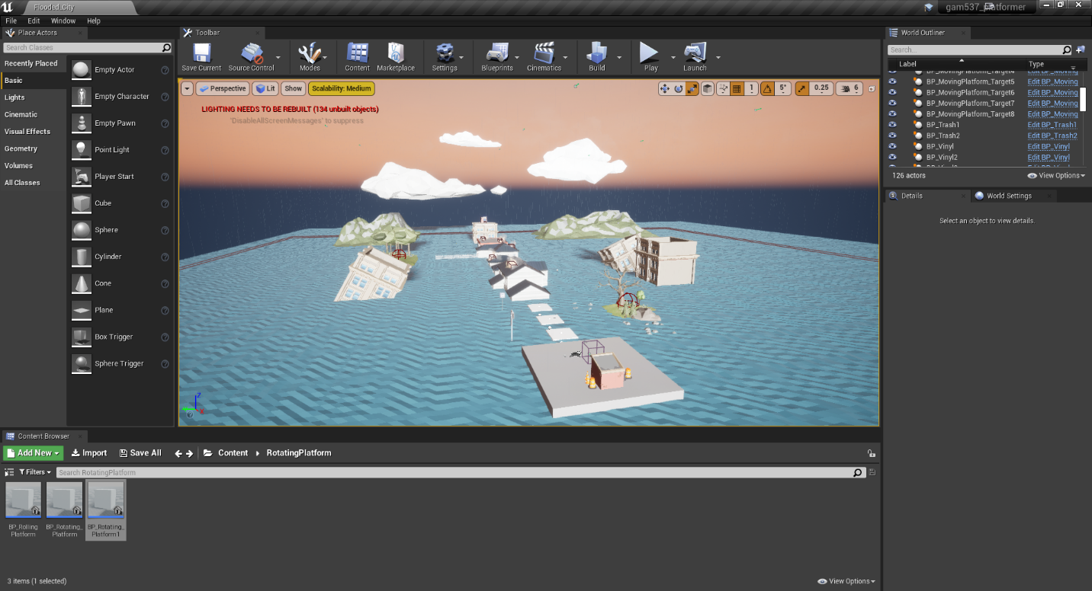

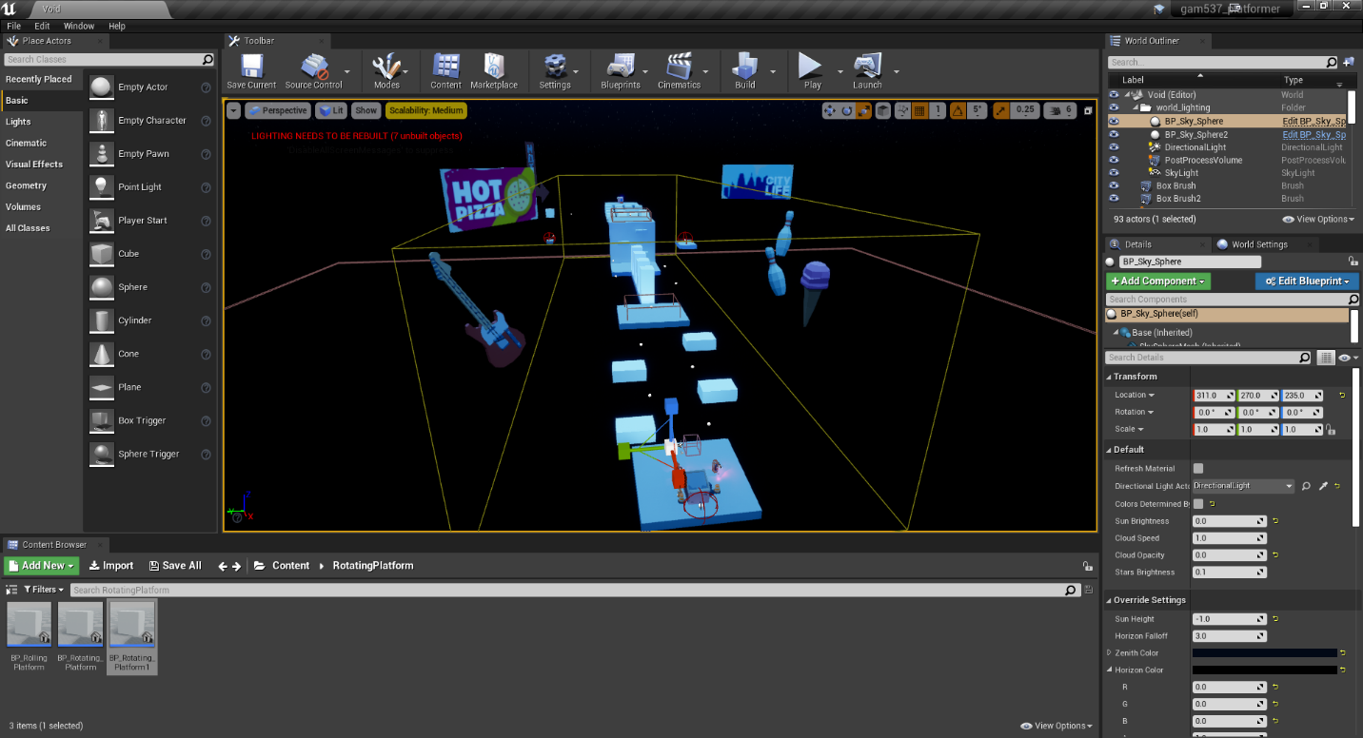

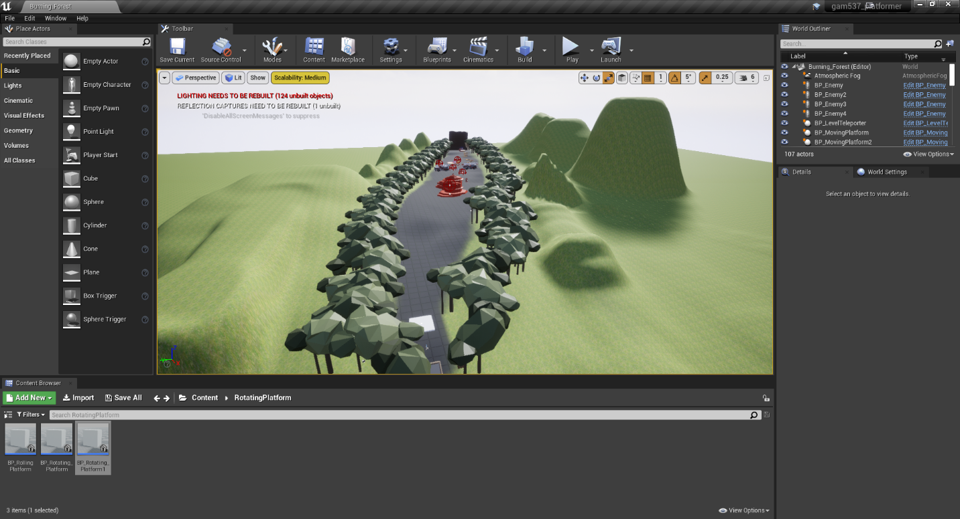

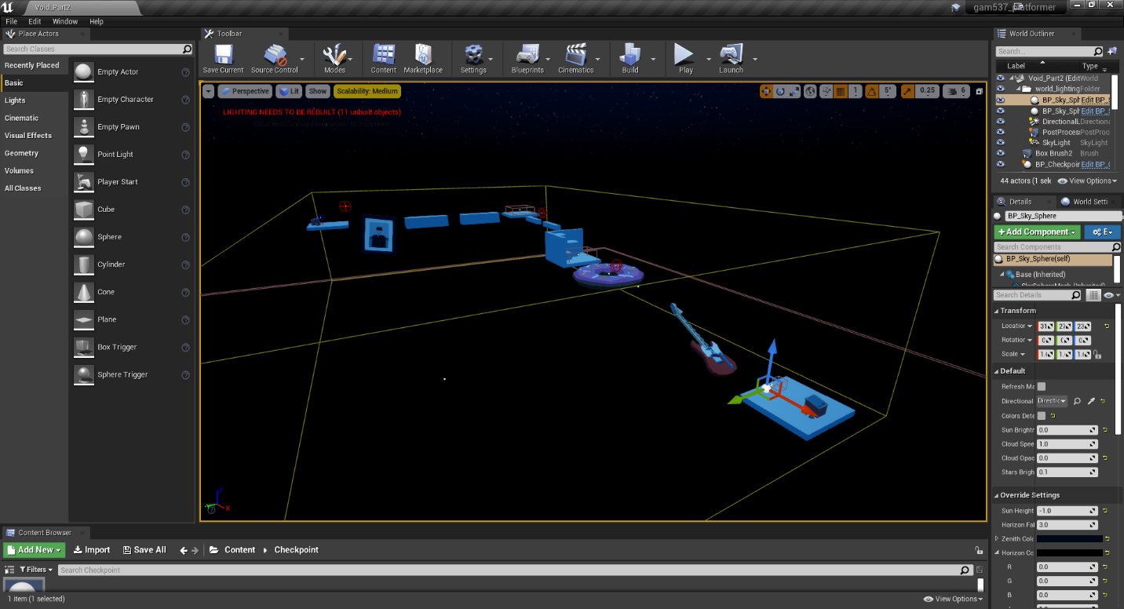

## Requirement: Ten Objects

**“A number of 10 objects designed in the Editor or designed in any other application or imported by any source…All the game objects should be Blueprints (except the Volumes) with complex colliders, physics and well-designed.”**

### BC_Checkpoint

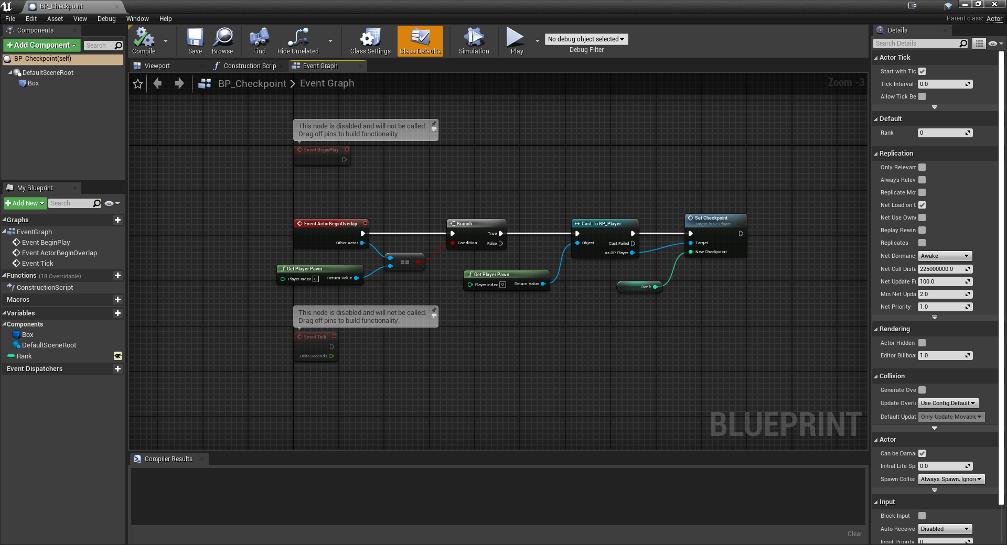

### BP_Enemy

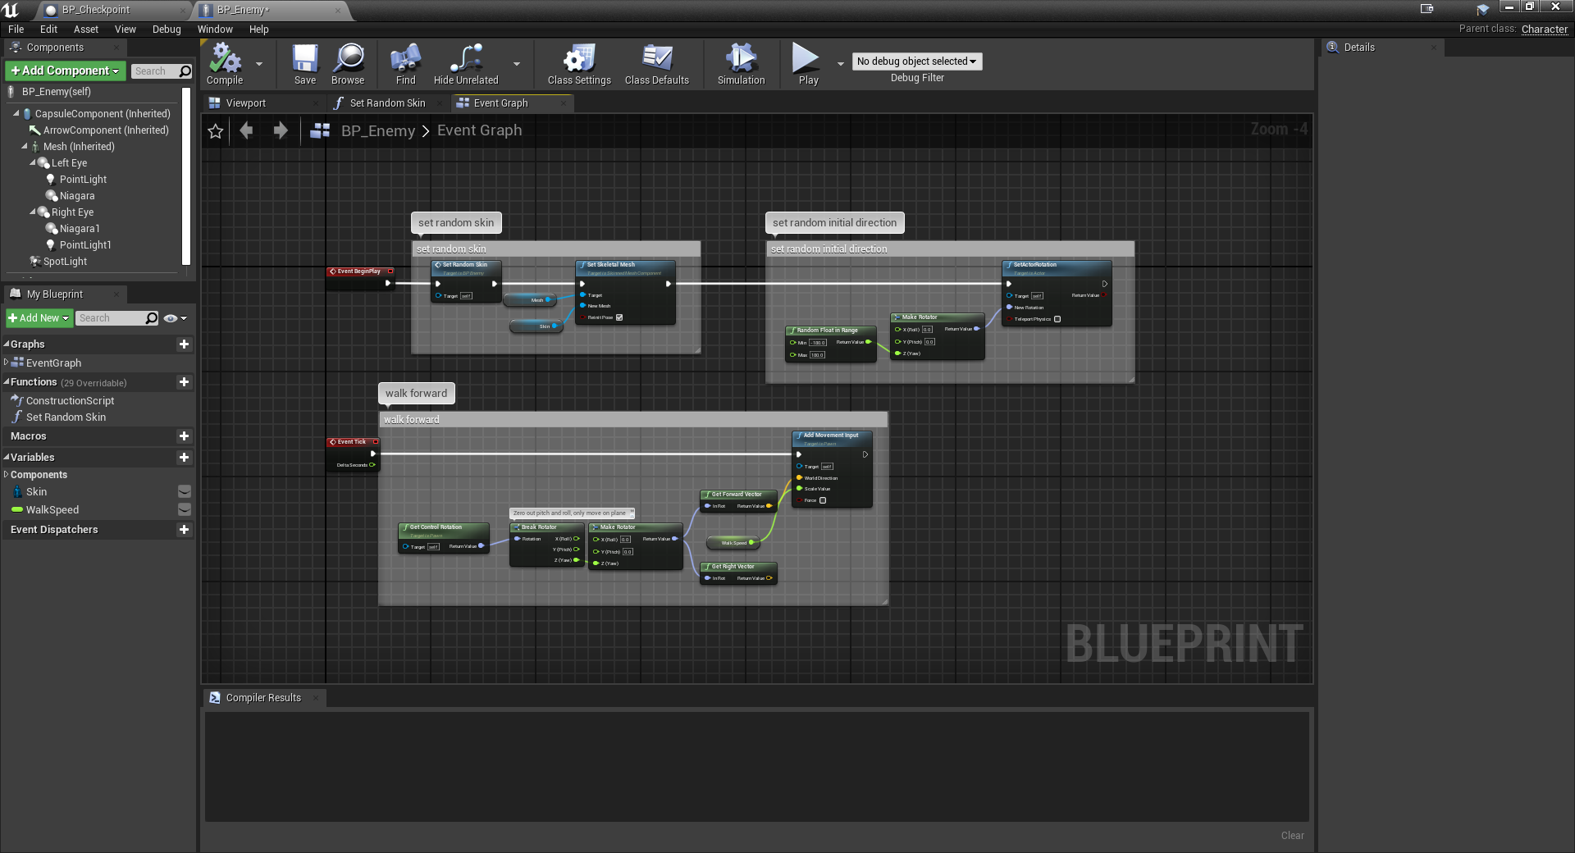

### BP_LevelTeleporter

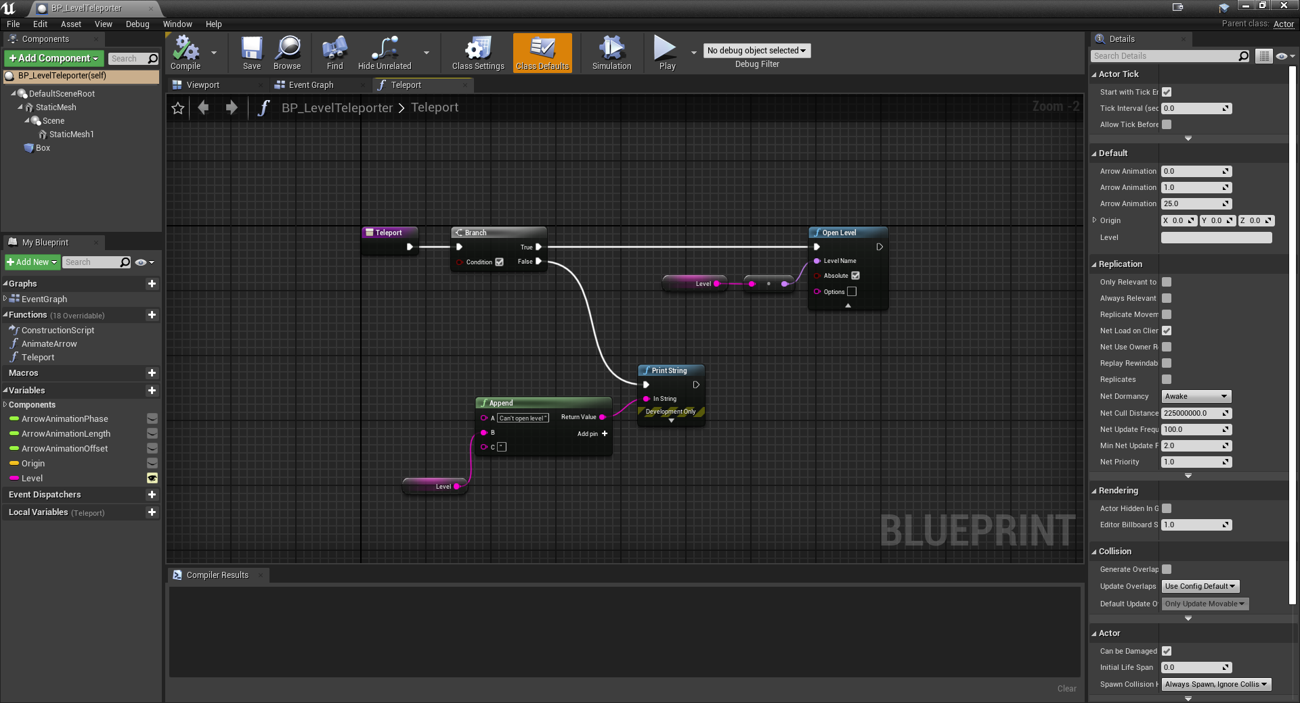

### BP_RotatingPlatform

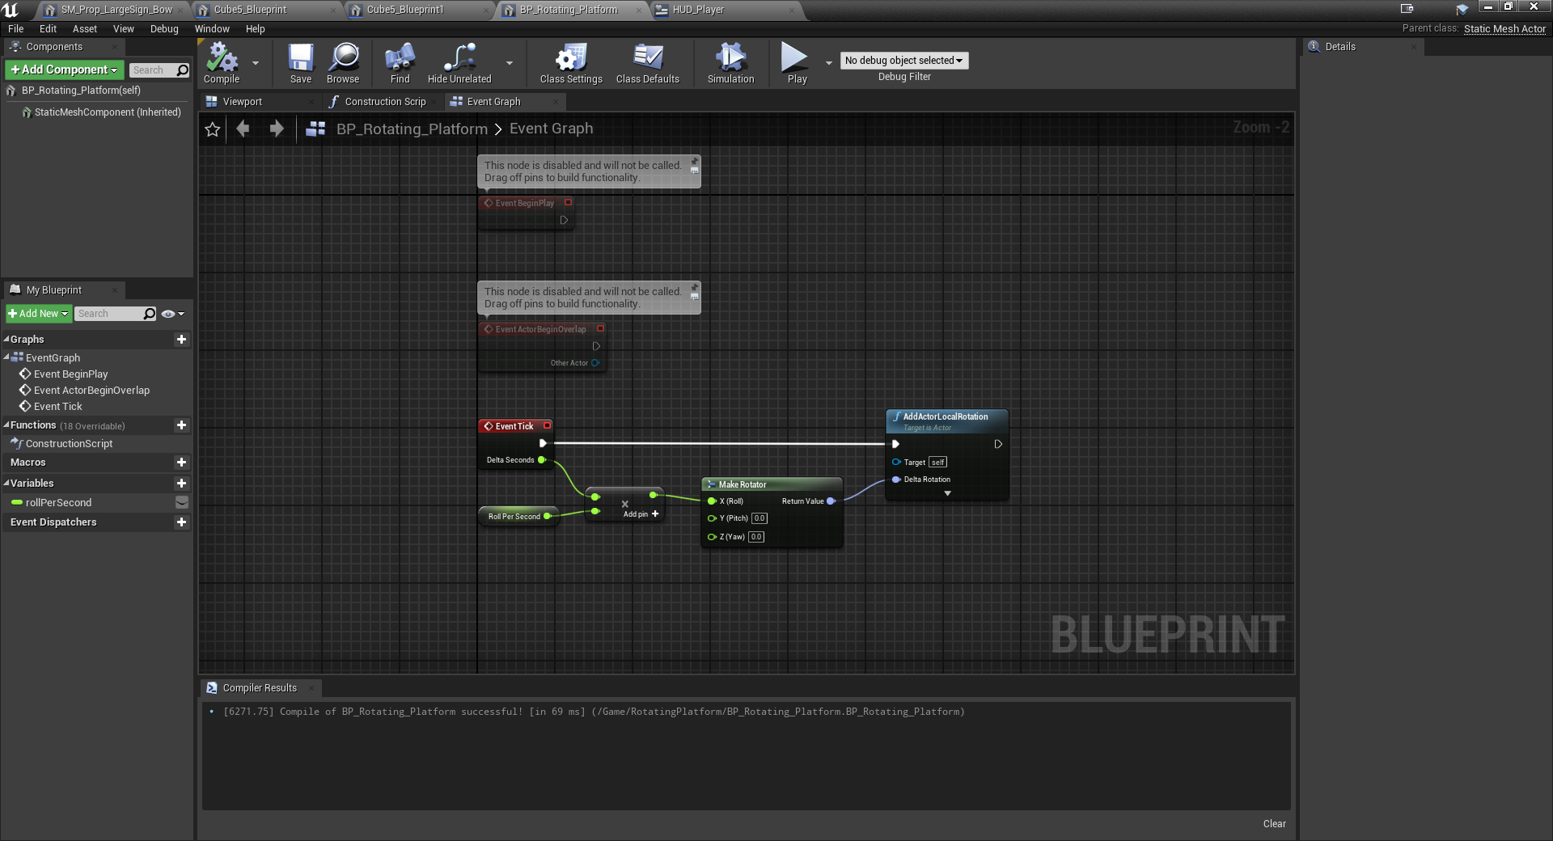

### BP_MovingPlatform

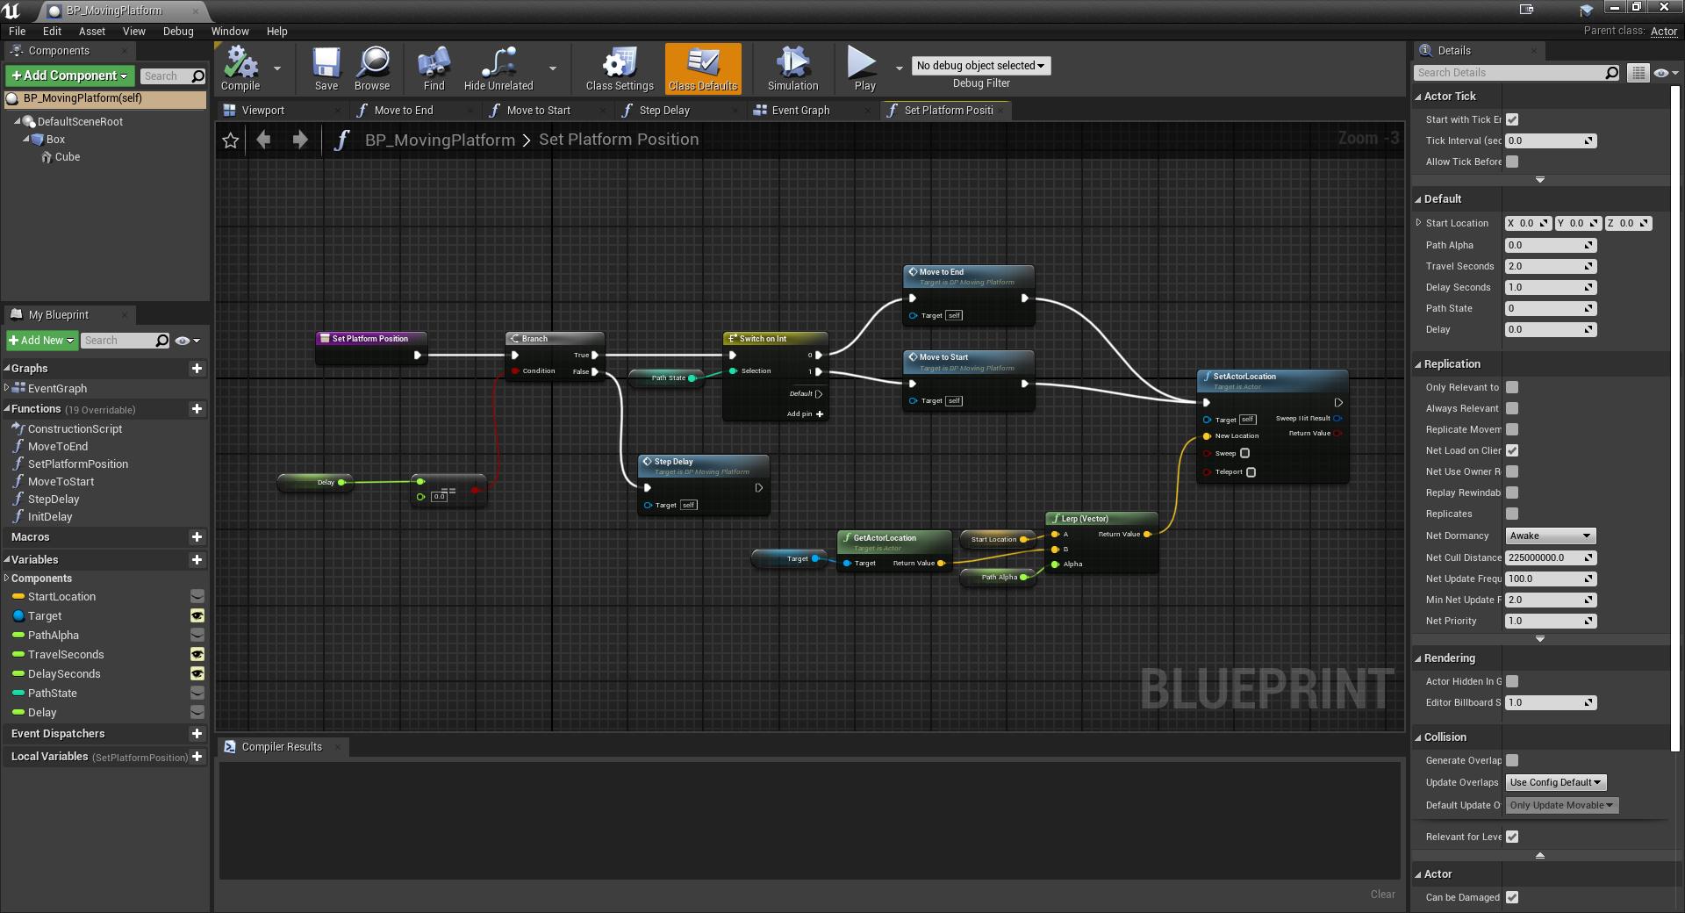

### BP_Cone1

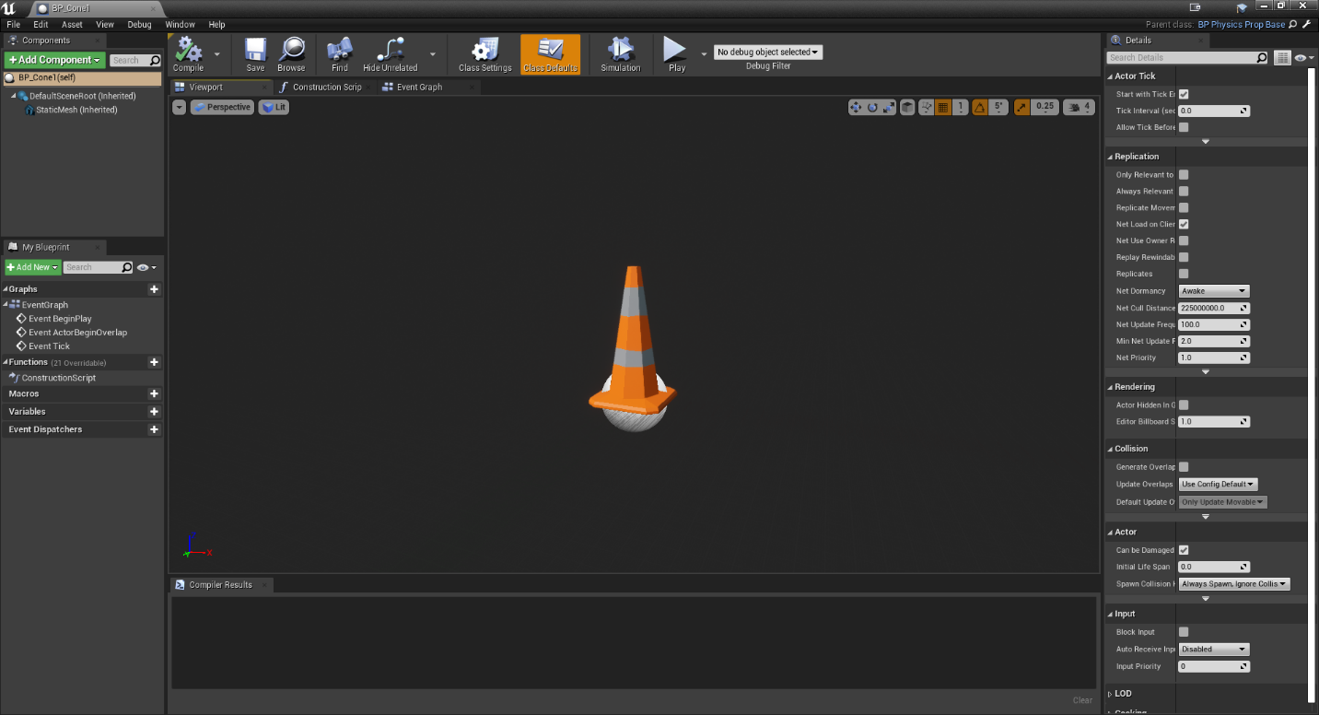

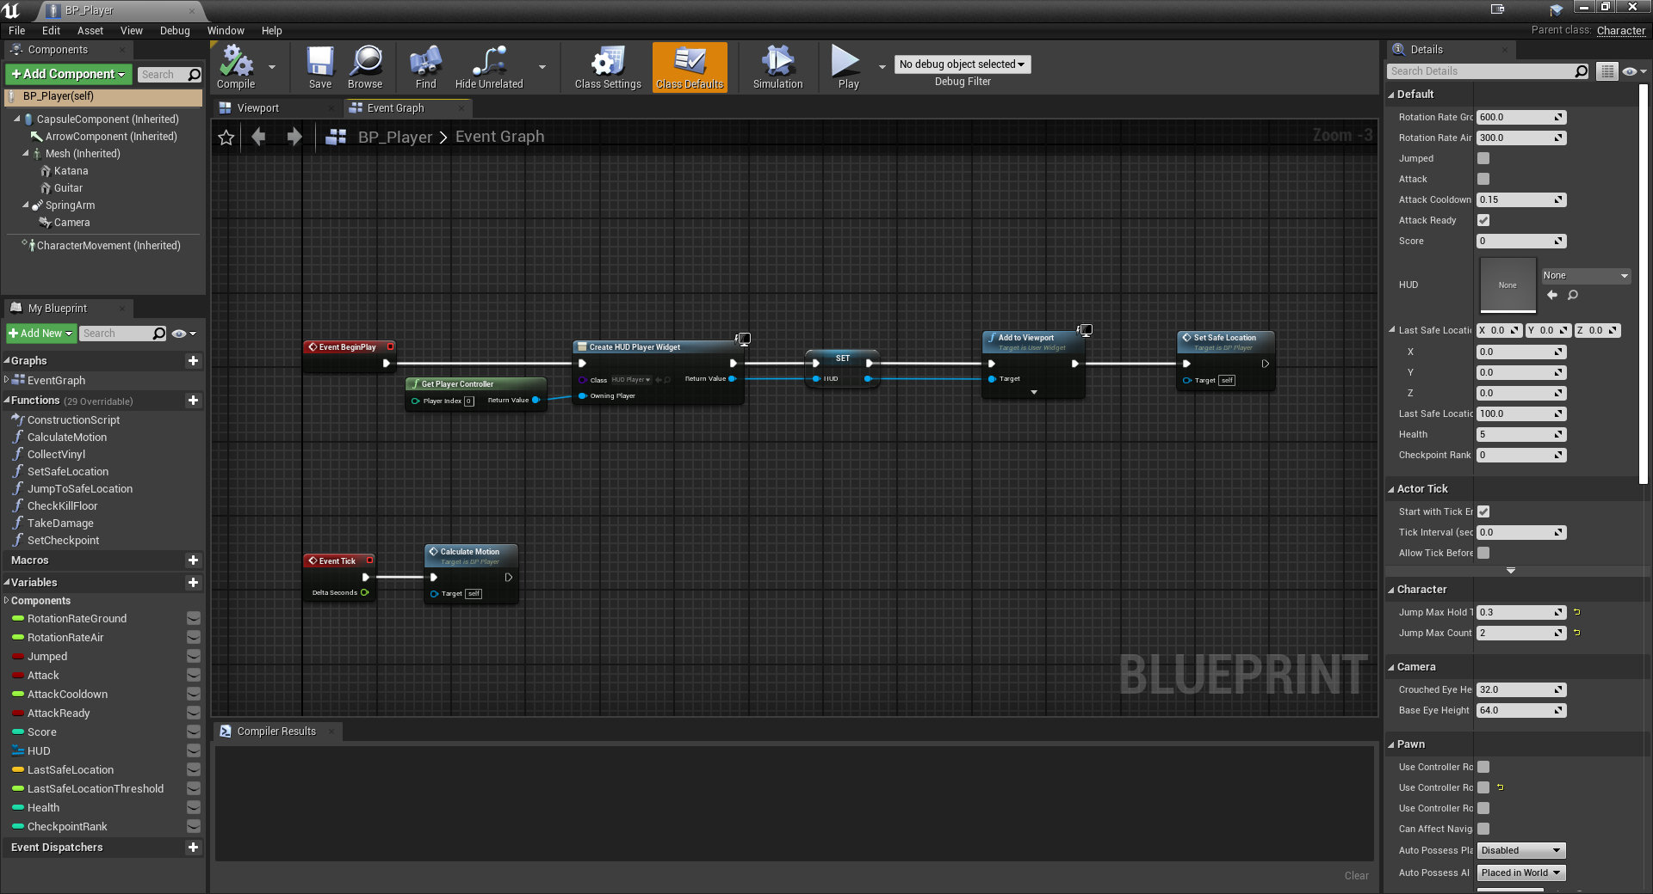

BP_SteamTrap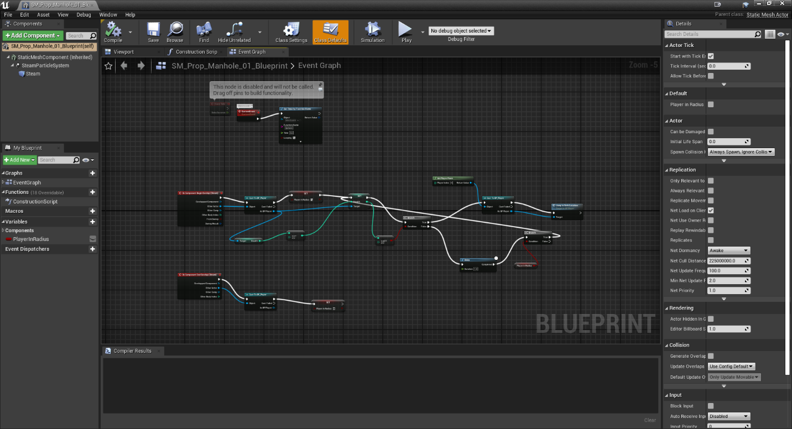

### BP_FireTrap

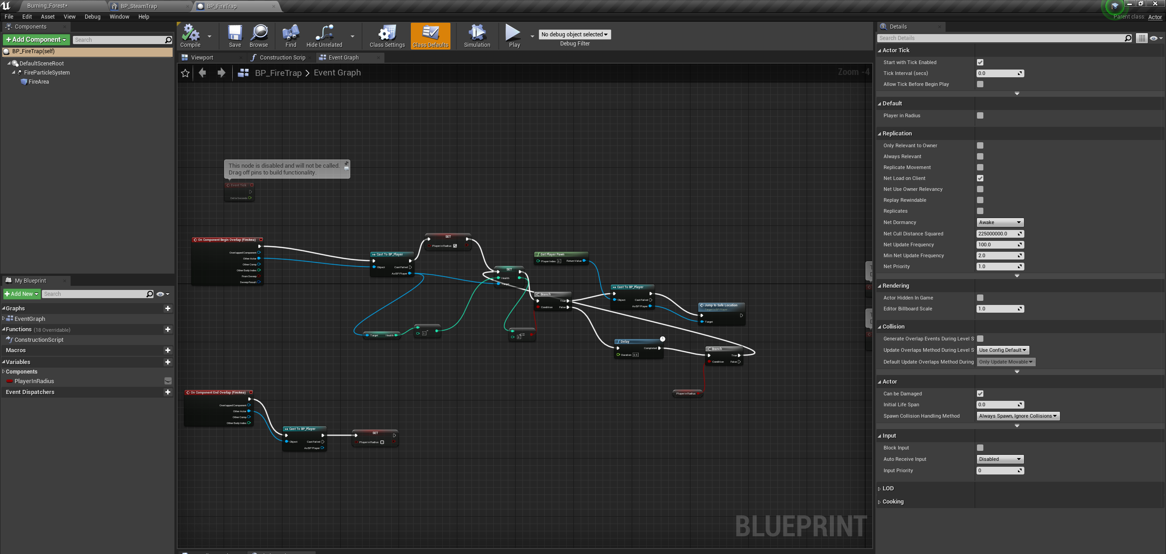

### BP_TelevisionLight

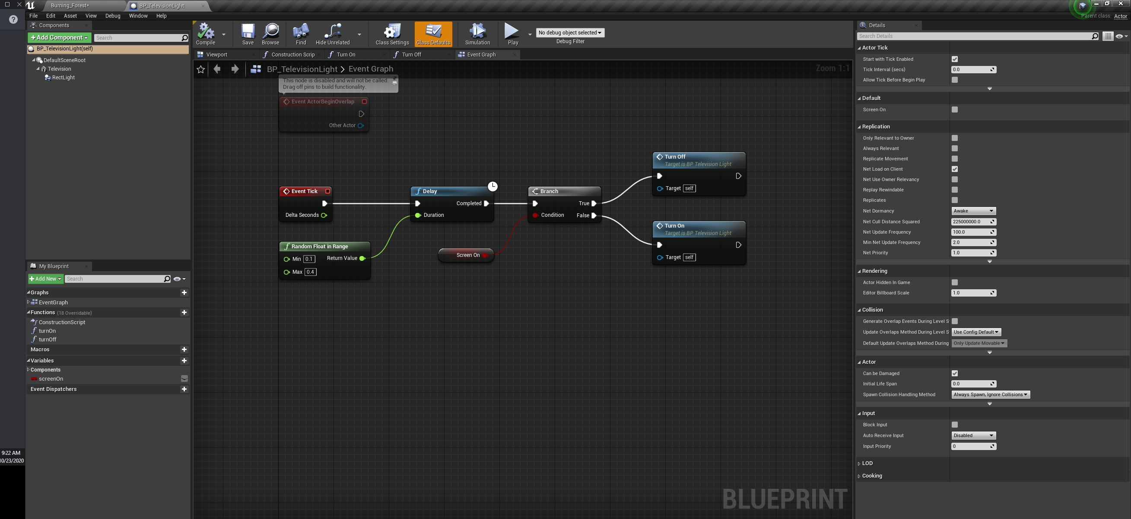

### BP_Vinyl

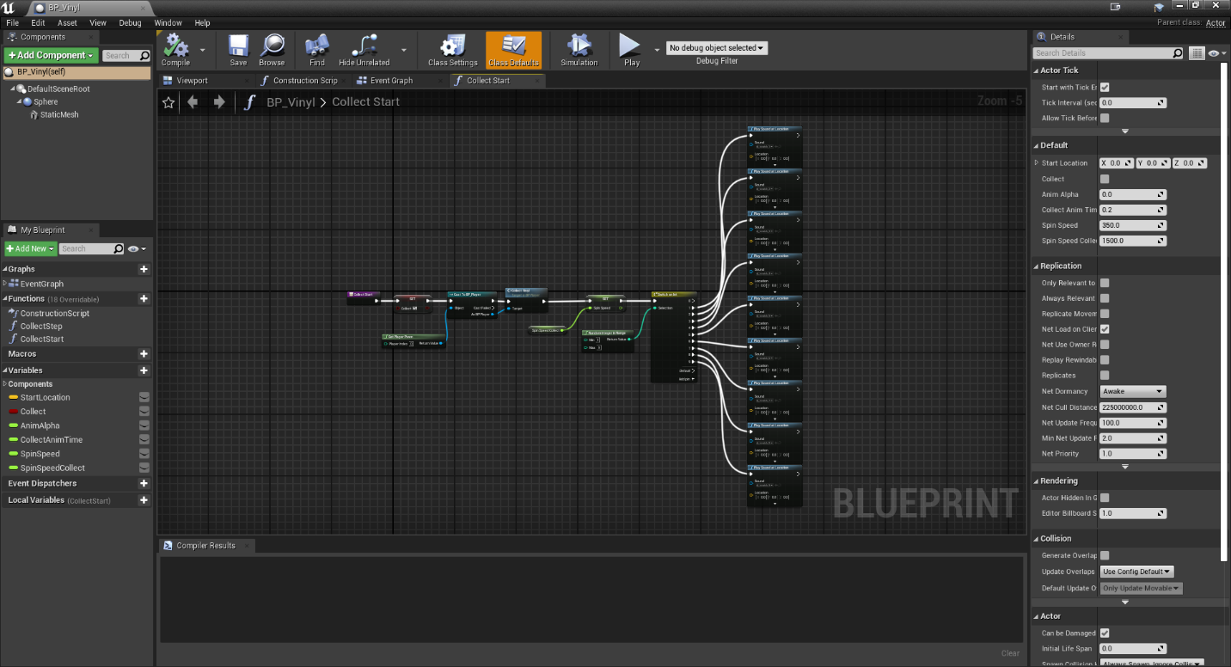

### BP_Cone2

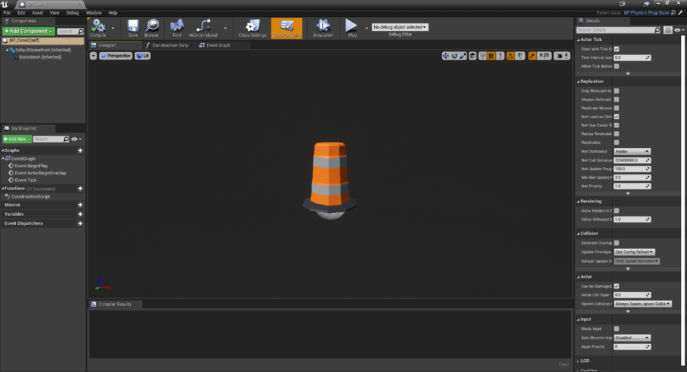

### BP_Trash1

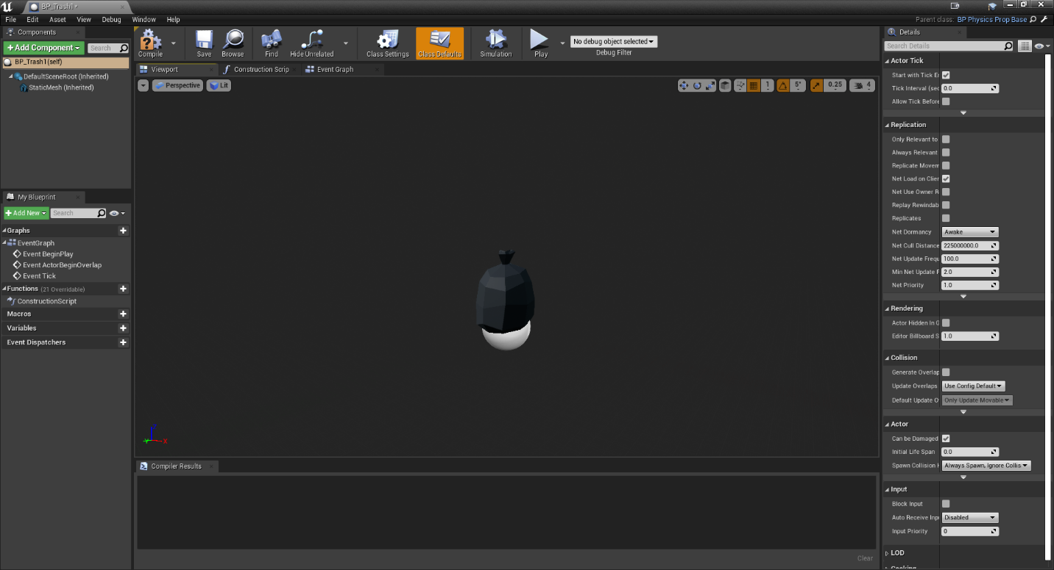

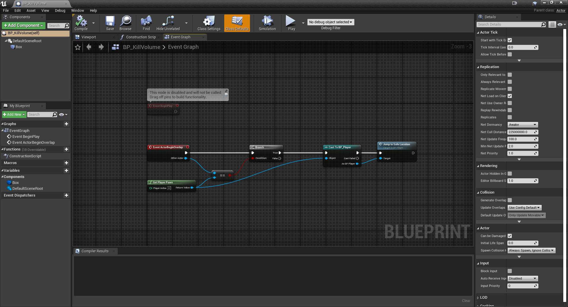

## Requirement: Player Character

**“A 3D Character with fully working keys, key binding, camera, collision, at least 5 animations (e.g. idle, walk, run, jump, death), apply transitions to animations, a score system based on the character (e.g. number of pickups count), a life system (e.g. count remaining lives).”**

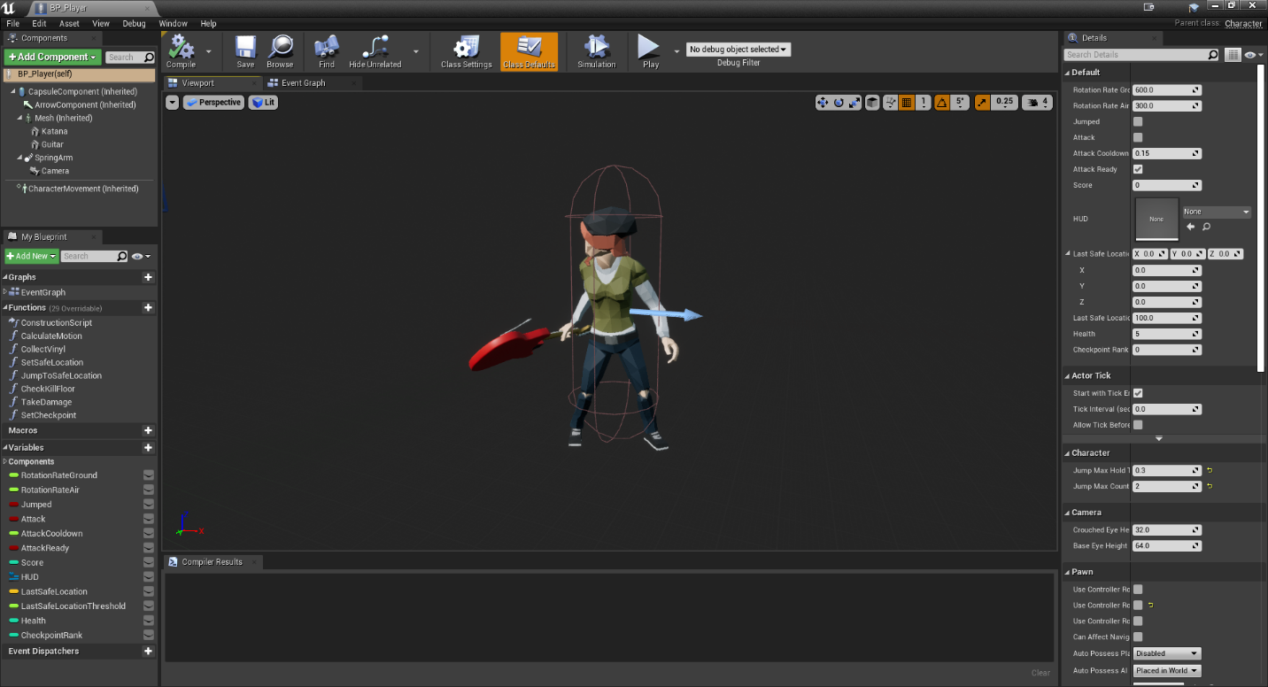

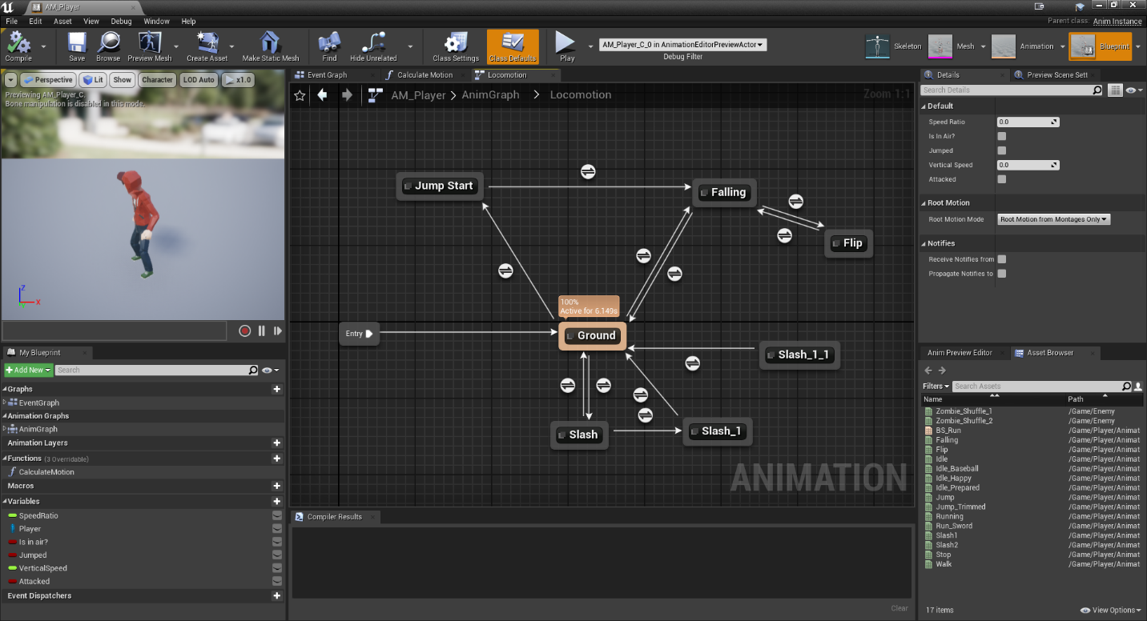

## Requirement: Lighting

**“Fully implemented lighting that includes at least a sky dome, a directional light, and a number of other lights (a exception could be an internal – underground world, where the sky dome – directional requirements are dropped). The lights should have some kind of functionality implemented with Blueprints.”**

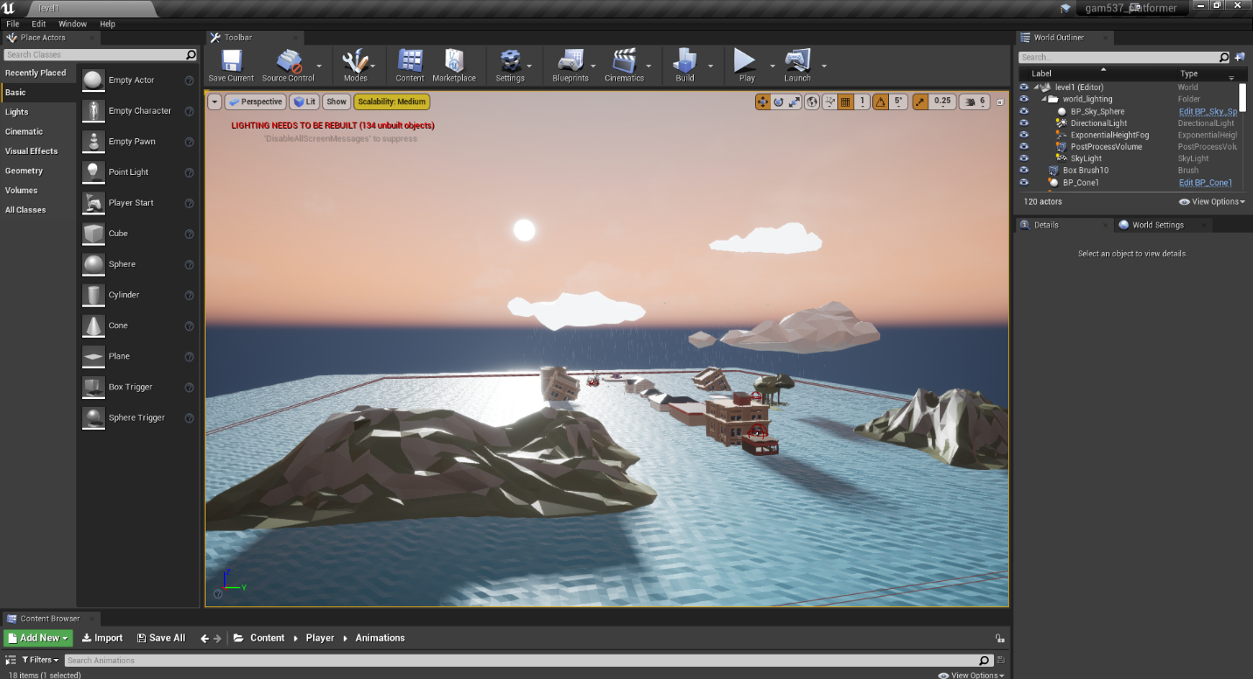

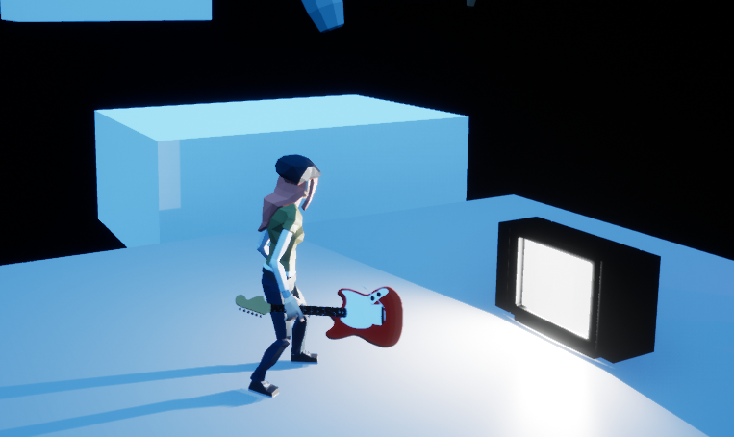

**Note:** TV light flickers on and off on a randomized timer implement via blueprints.

## Requirement: UI

**“A well-designed User Interface that displays information about the level and the character (e.g. level name, number of lives etc).”**

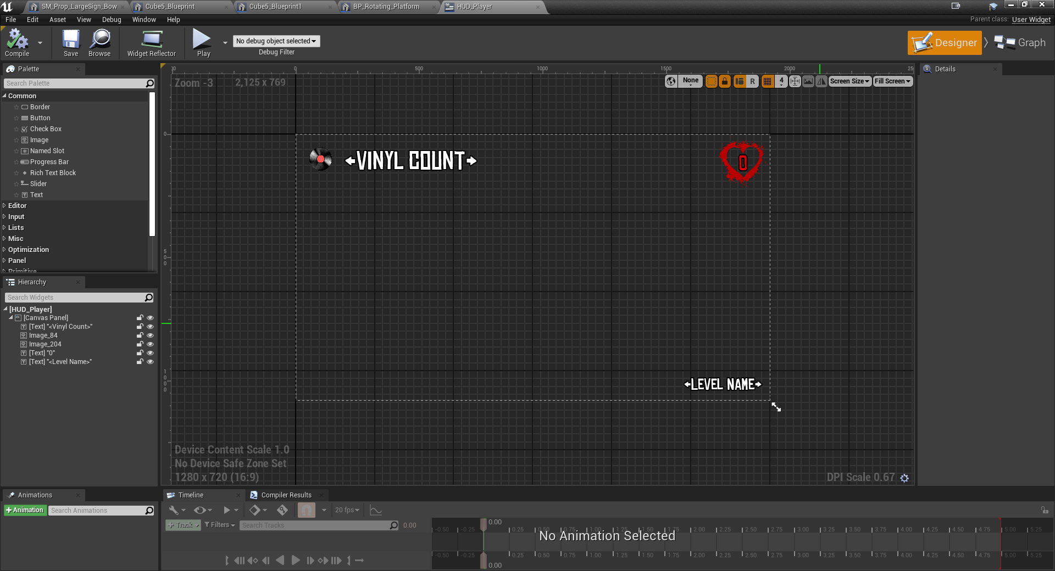

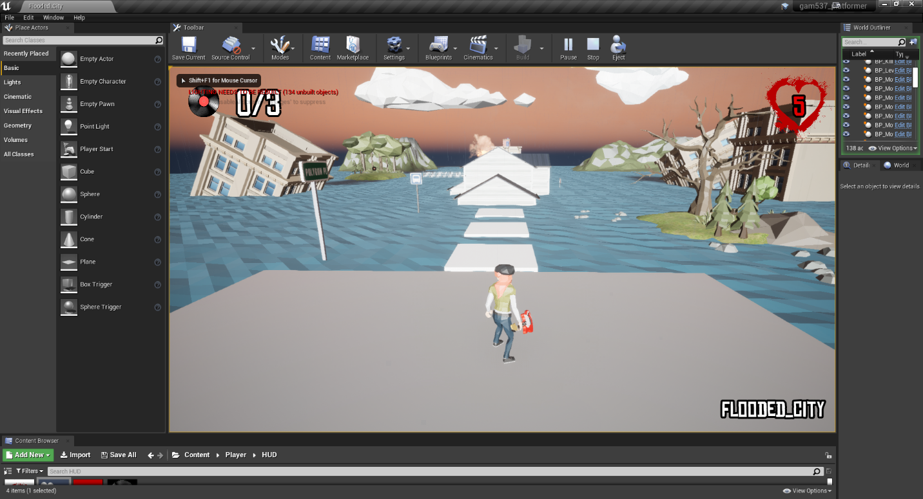

## Requirement: Terrain and Level Design

**“Every level should include a terrain, with some kind of vegetation or multiple objects that create the impression of a real world, that can host a game level.”**



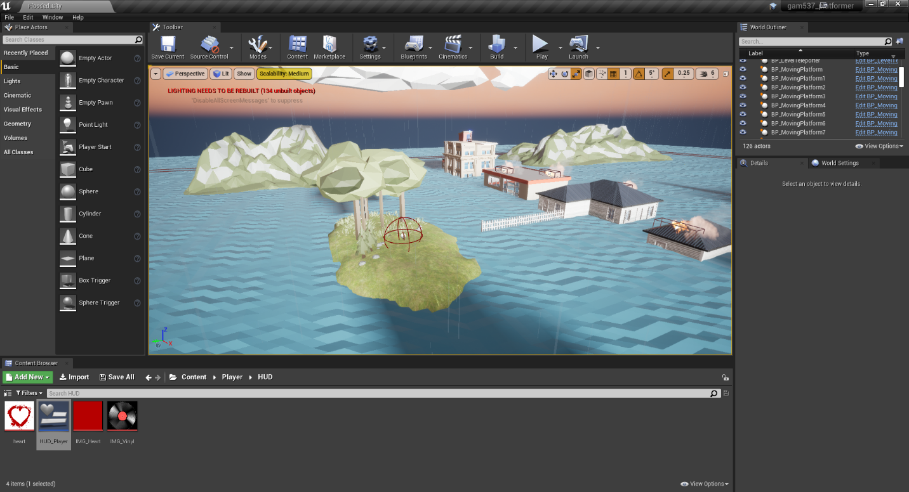

## Requirement: Enemies and NPCs

**“At least 10 different Enemy or NPC types, with different behaviors and settings with: AISensing. Behavior Trees. Blackboards. AIControllers.”**

*Examples of AI functionality for one NPC (shambler) included below. To find functionality for other AI please open the project and navigate to their respective folder under NPCs.*

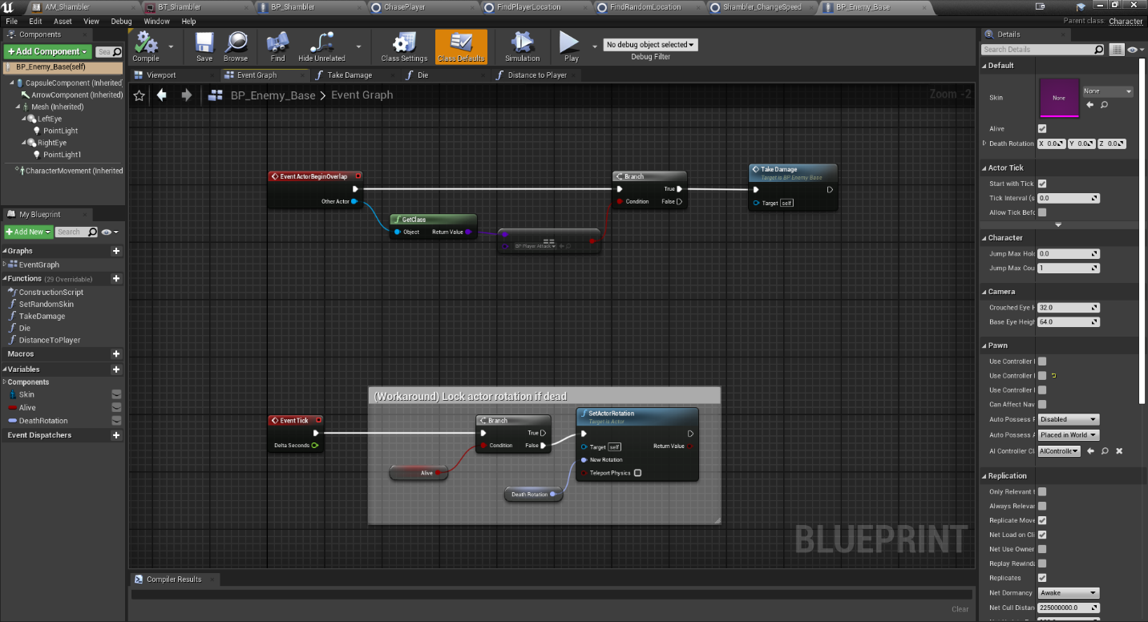

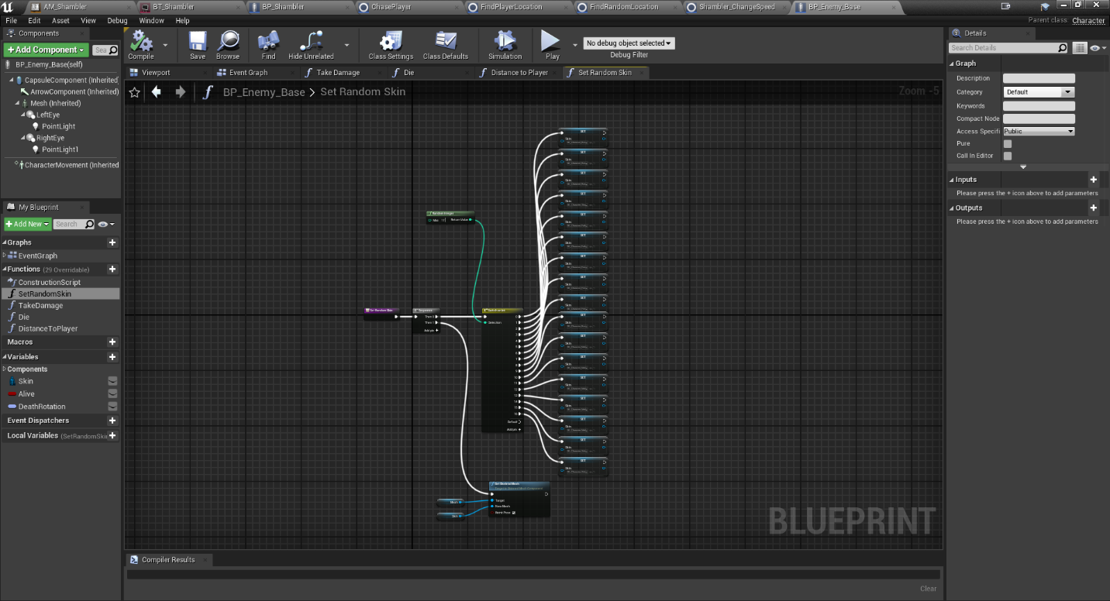

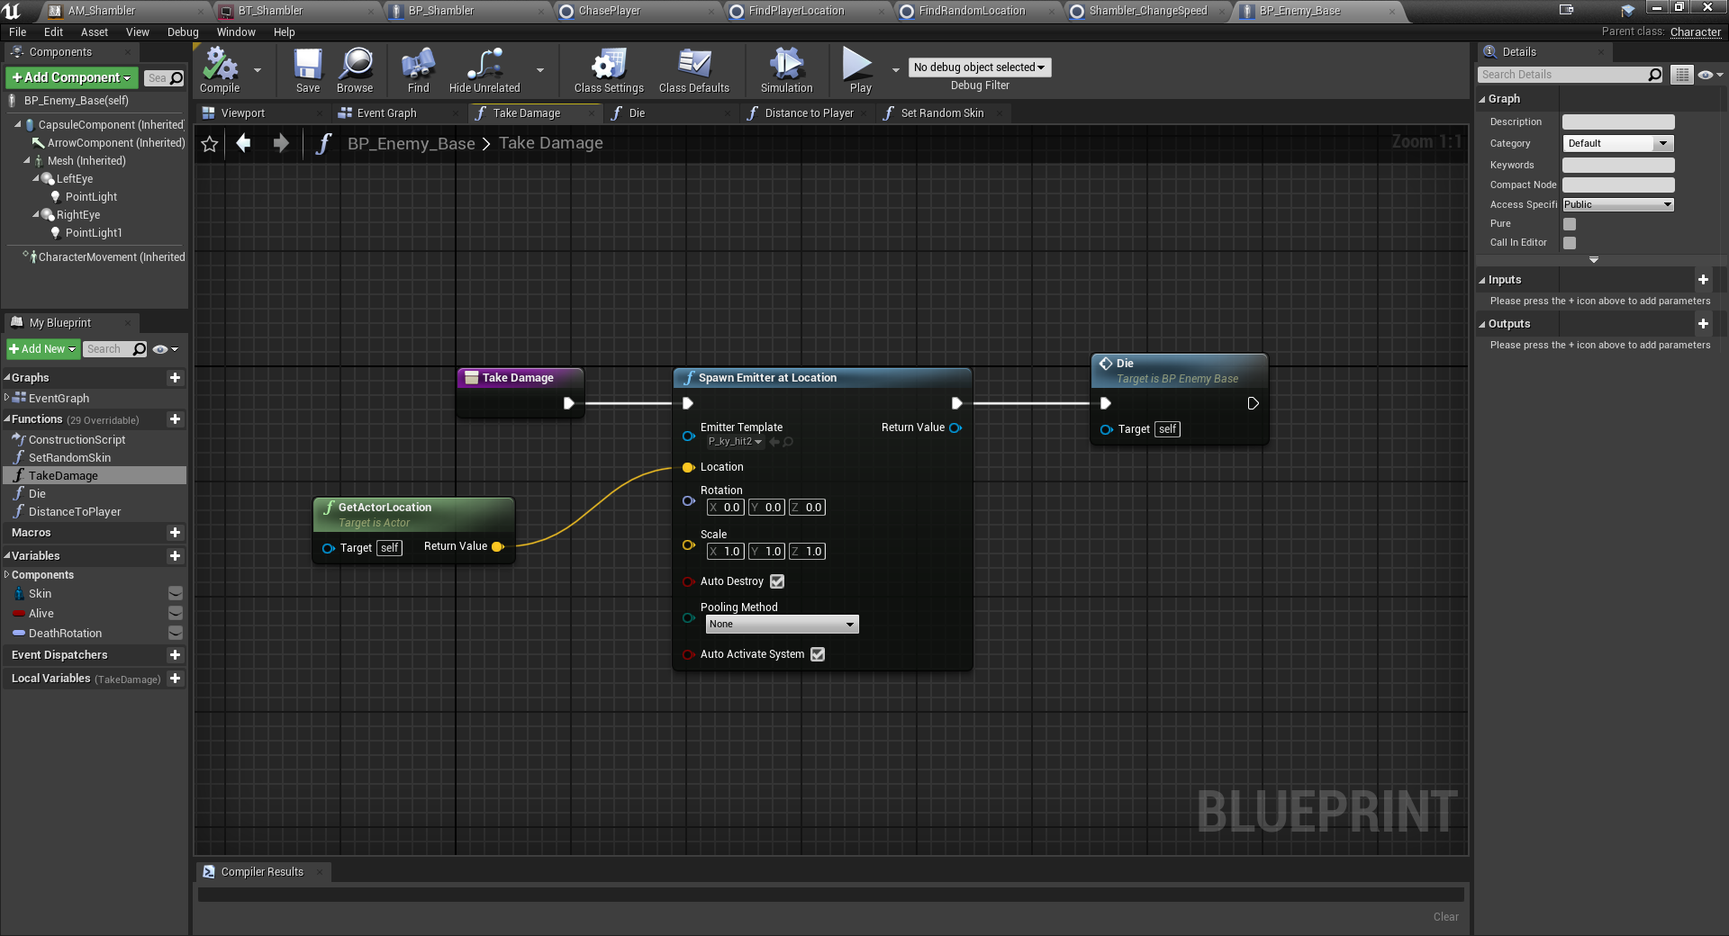

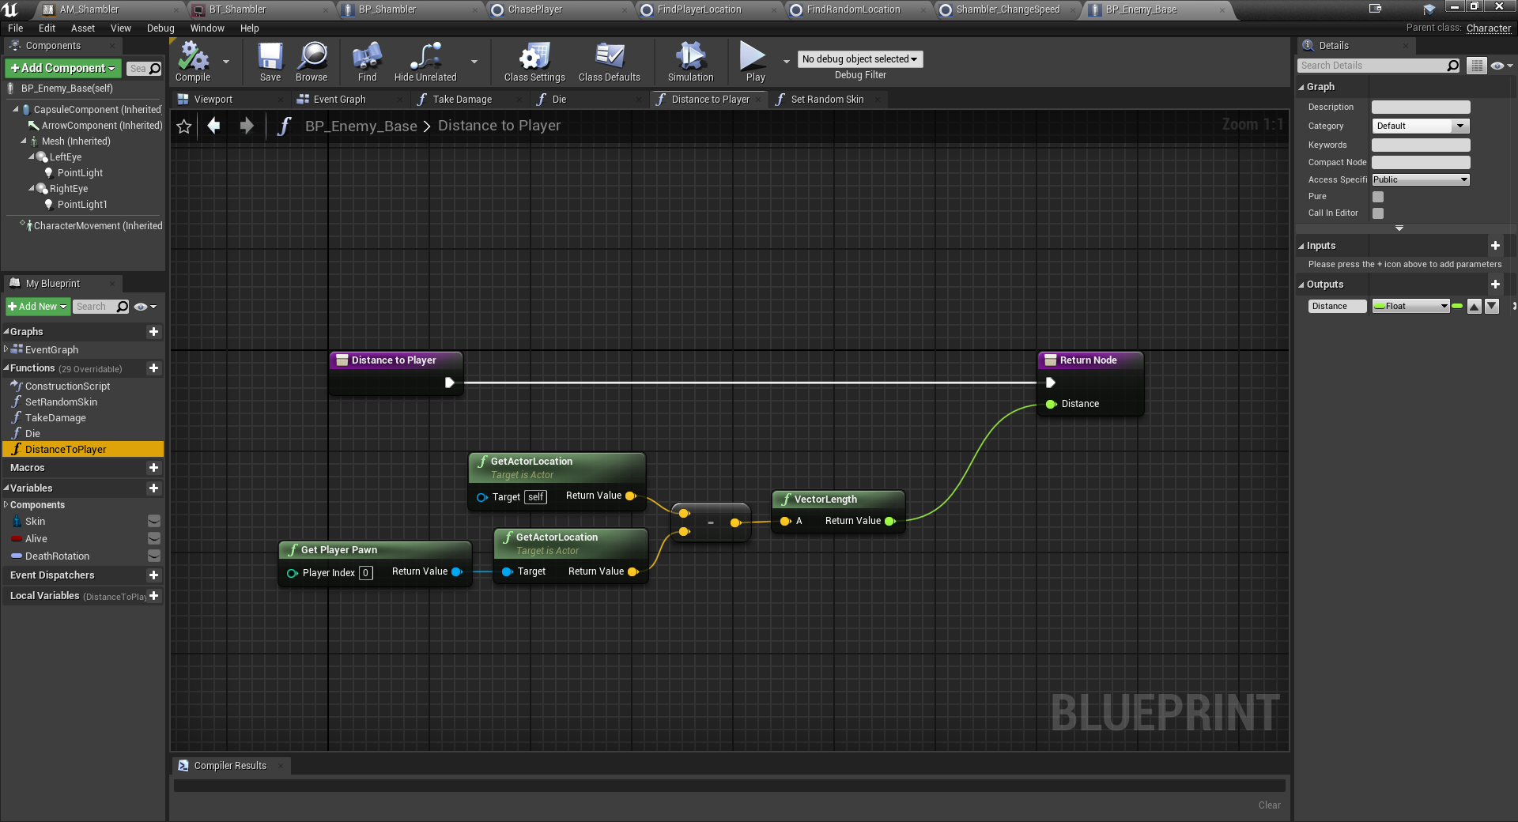

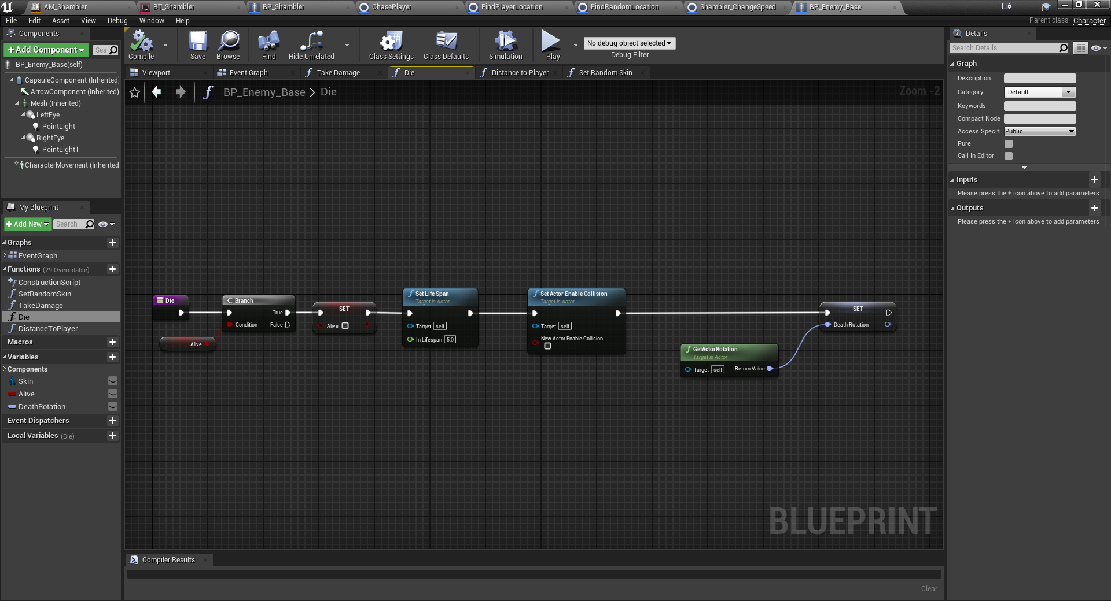

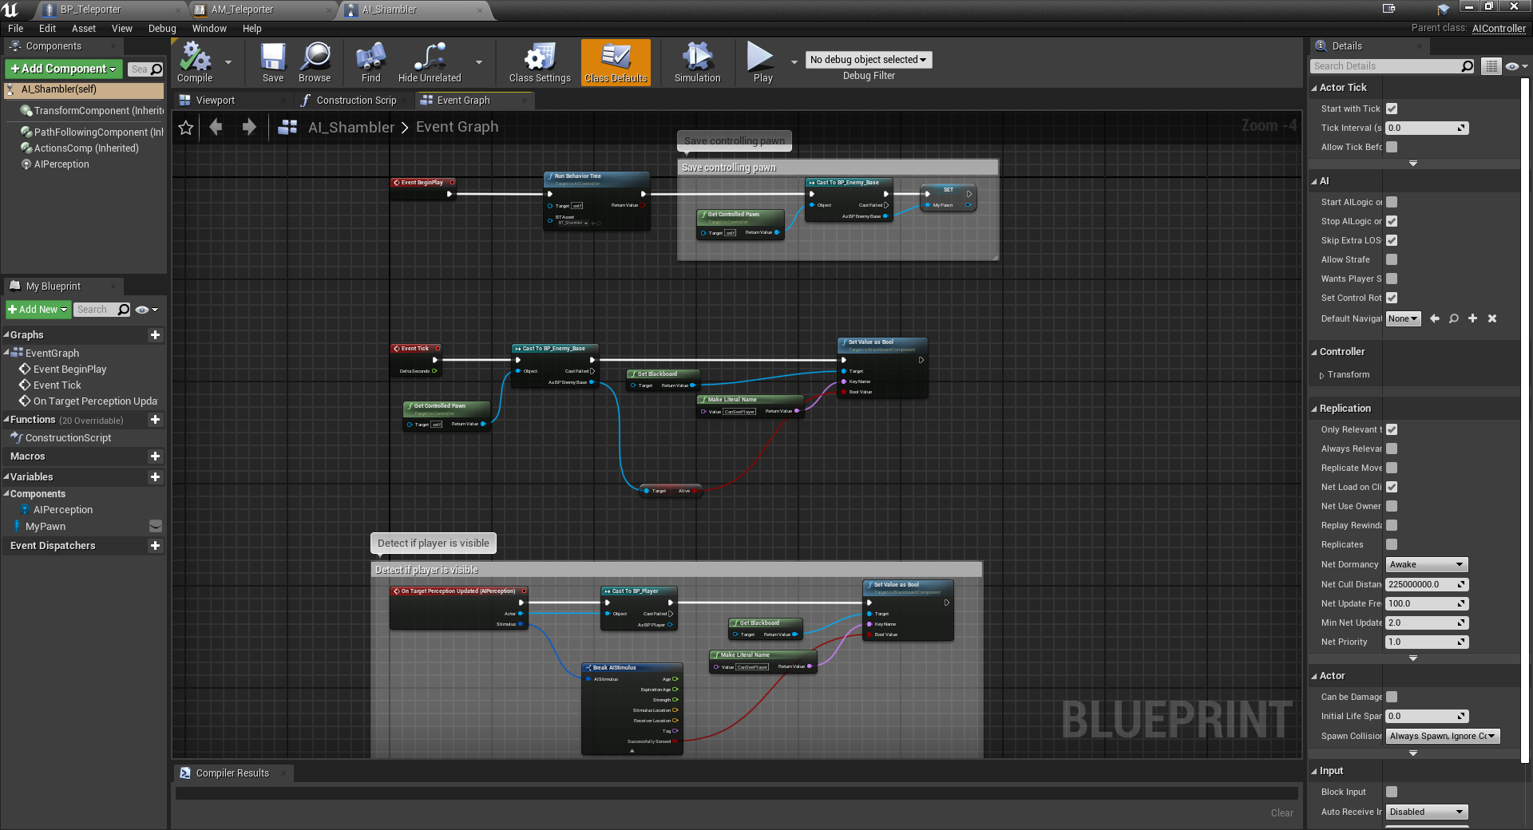

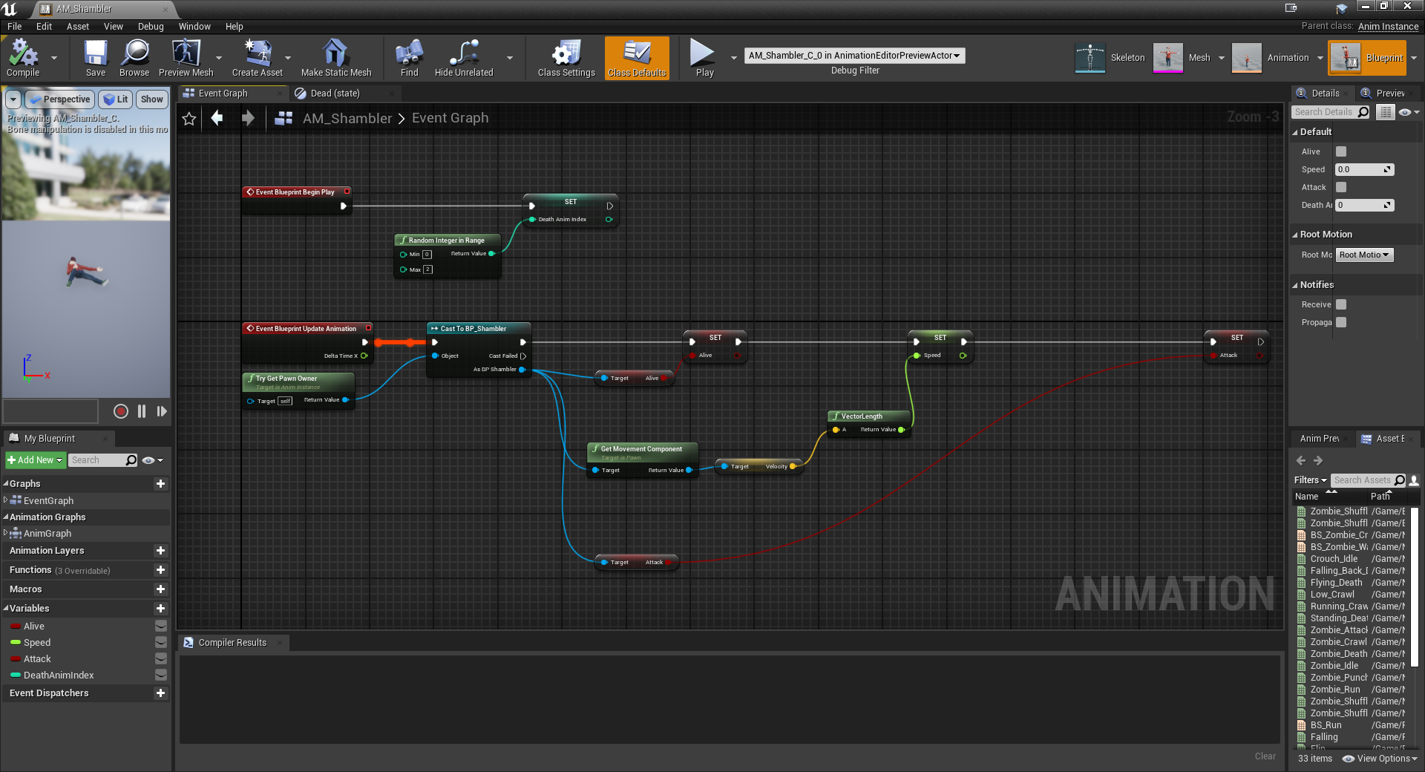

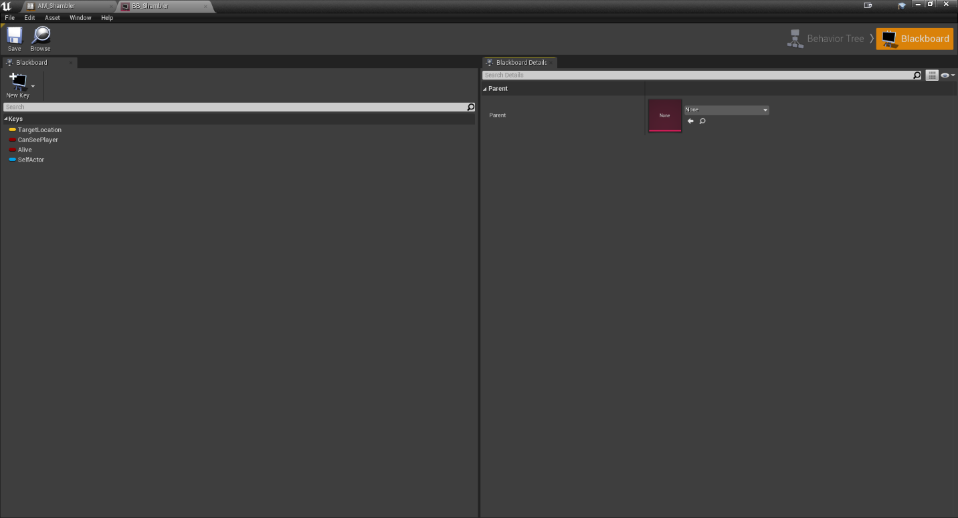

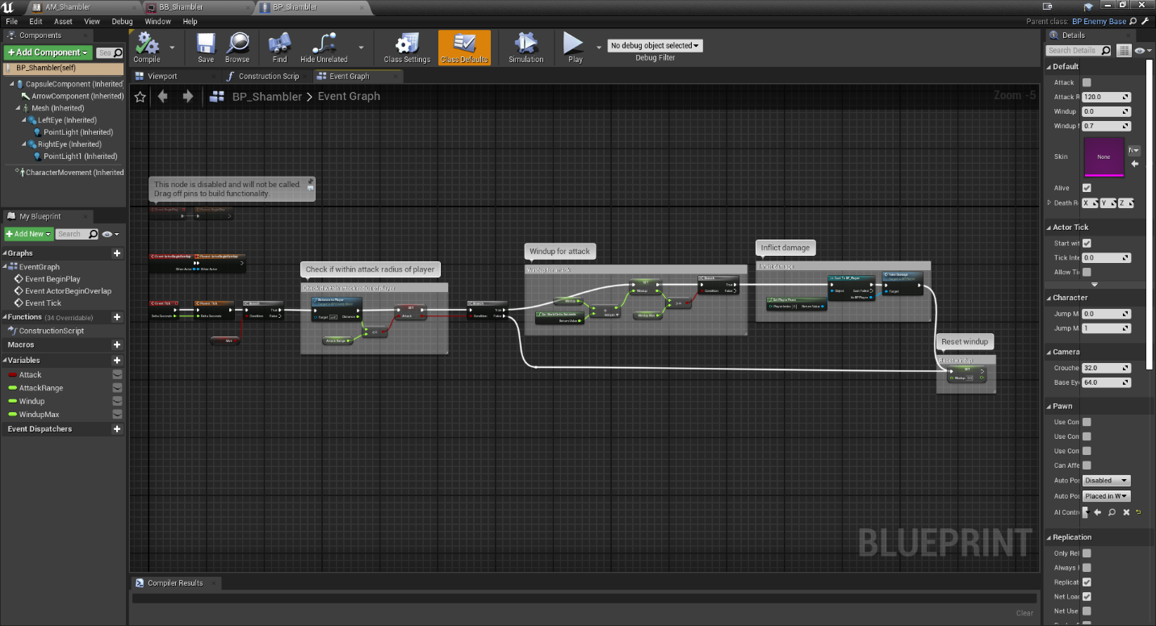

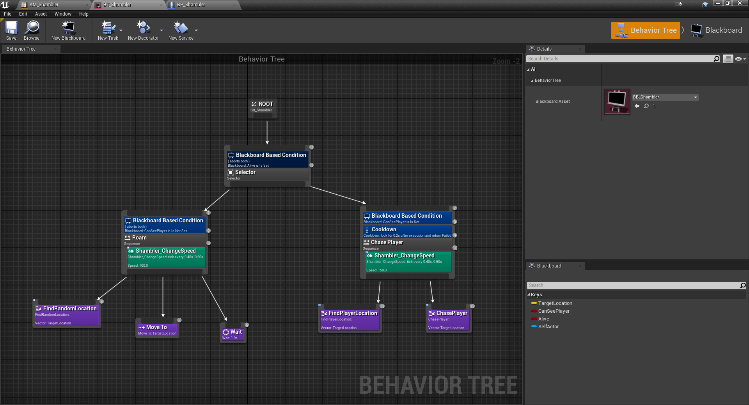

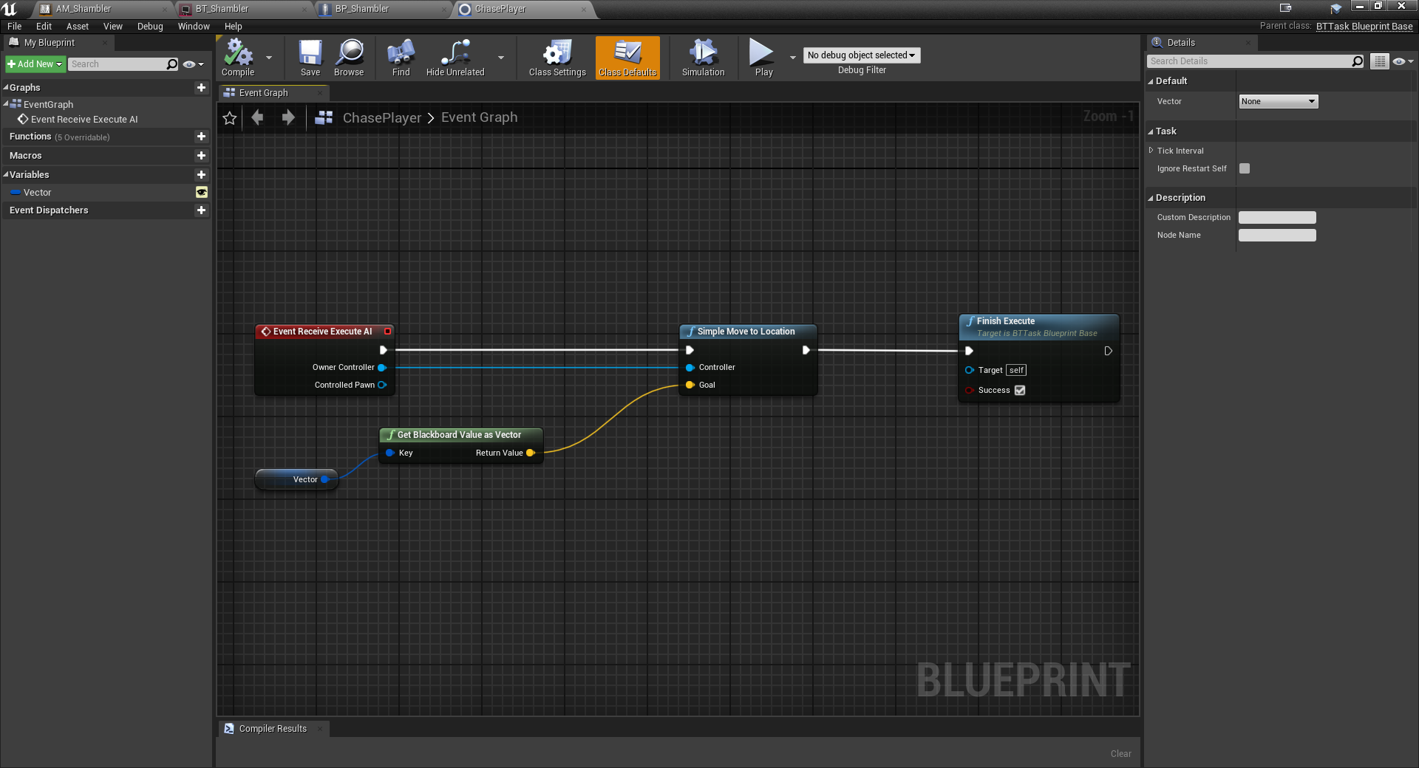

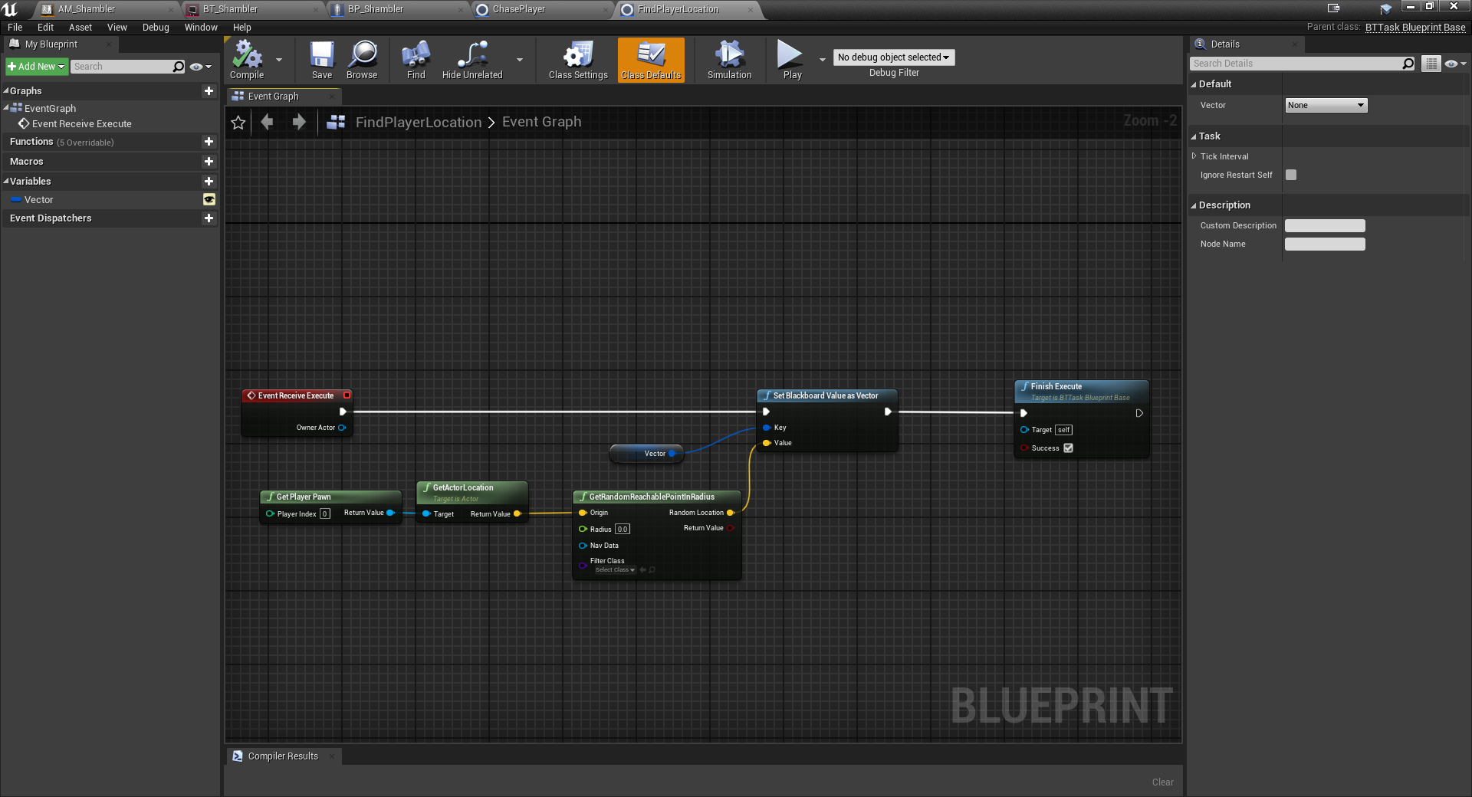

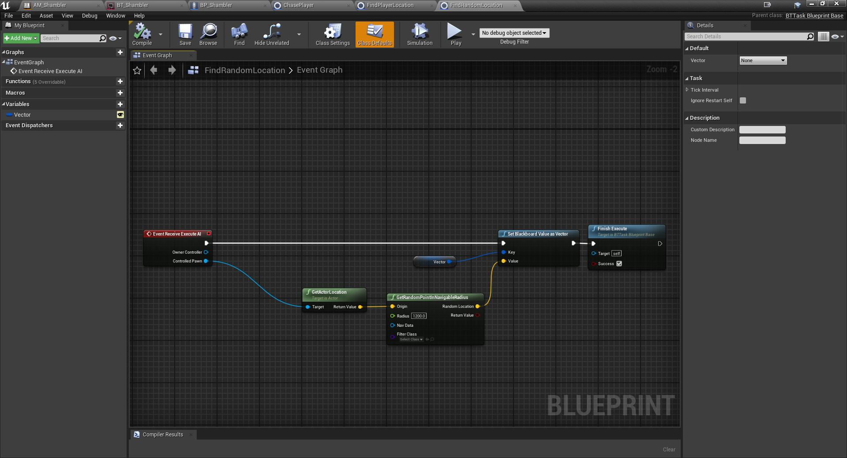

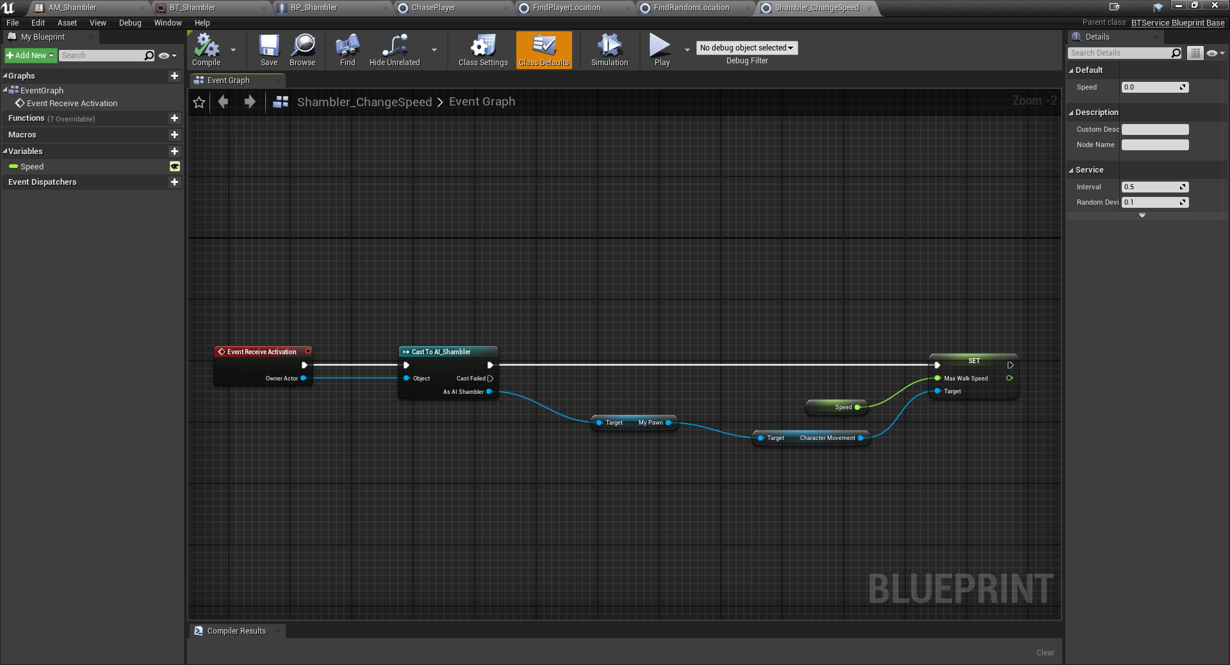

## Requirement: Persistent Count

**“A well-designed advanced and dynamic User Interface that displays information about the level and the character (e.g. level name, number of lives etc). The count should not be reset when the player opens a new map or level.”**

